**Experimental Investigation of Hydrostatic Vacuum Tube Drained Water as a Function of Initial Water Height**

Jiah Jin, Jason Chen, Joseph Sutton

The Cooper Union for the Advancement of Science and Art

April 6, 2023

ME-360-C Engineering Experimentation

Professor Sidebotham

**Experimental Investigation of Hydrostatic Vacuum Tube Drained Water as a Function of Initial Water Height**

Jiah Jin, Jason Chen, Joseph Sutton

The Cooper Union for the Advancement of Science and Art

April 6, 2023

ME-360-C Engineering Experimentation

Professor Sidebotham

# 

# Abstract:

The concept of a vacuum and its applications can be difficult to understand, even for some engineering students. In order to help students better understand vacuum creation, the Hydrostatic Vacuum Tube (HVT) experiment is designed to visually demonstrate this concept. In this experiment, there is a clear main vertical tube that is partially filled with water. Above the water, there is a clearance volume trapped by an isolation valve. The initial height of the water before draining is recorded. Then a nozzle, with a diameter small enough such that there is no backflow of air, is opened and water is drained into a cup until the system reaches a mechanical equilibrium due to the pulled partial vacuum. After reaching equilibrium, the amount of water is weighed and recorded. The relationship between the initial water level and the corresponding mass of water collected is initially unintuitive. However, the derived theoretical model using the Ideal Gas Law and the Hydrostatic Equation, closely predicts actual data collected by students. The Experimental Section provides details on the apparatus, materials used, and procedure. Initial analysis of the data collected is included in the Results Section. Complete analysis, such as the theoretical model derivation, identification of outliers in the data, and experimental uncertainty is outlined in the Discussion Section.

# 

# Introduction:

The concept of vacuum creation and its applications are important in many engineering fields, including mechanical engineering. An important real-world example of this is residential plumbing vents. An air vent is required on the roof to prevent a partial vacuum from forming above waste water when using toilets or sinks. Otherwise, if a vacuum forms, it could impede the drainage process.[1] However, understanding the principles of vacuum creation can be challenging for some students without a practical demonstration.

This paper aims to provide a comprehensive description of the Hydrostatic Vacuum Tube (HVT) experiment, including the apparatus and experimental procedure, theoretical model derivation, and analysis of experimental uncertainty. By conducting the HVT experiment, students can enhance their understanding of vacuum creation and associated principles, which can be applied in real-world engineering scenarios.

The main tube in the experimental apparatus is transparent, providing students with a visual representation of the physics behind the HVT experiment. Students can observe the water level before and after drainage, enabling them to see how a partial vacuum results in a hydrostatic mechanical equilibrium even with an open nozzle at the bottom. Additionally, the visual cues assist students in developing an equation to model the experiment. Students are able to compare their free body diagrams and equations to the physical behavior of the system. This helps to prevent mistakes and enhances understanding of the governing equations.

# Table of Contents:

**Abstract: 2**

**Introduction: 3**

**Table of Contents: 4**

**Experimental: 5**

The Apparatus 6

Instrumentation 11

The Procedure 14

**Results: 17**

Overview of Data 17

Uncertainties in Data 26

Linearization and Fit Line: Case Study Group C4 28

**Discussion: 31**

Variables Used for Derivation 32

Ideal Gas Law Analysis 33

Hydrostatic Equation Analysis 34

Combining Both and Arriving to Final Model 35

Comparison of Theory to Actual Data: Case Study 37

Propagation of Error 39

Comparison of Theory to Actual Data: All Valves & Closed Manometer 40

**Conclusion: 42**

**Recommendations: 43**

Improvements for Procedure 43

Improvements for Apparatus 43

**References: 44**

**Appendix I: Raw Data 45**

**Appendix II: Erroneous Data & Correction 57**

Kept Datasets: Group A4, B4, C3 57

Discarded Datasets: Group B1, C1 60

# 

# **Experimenta**l**:**

In this section, the testing protocols to measure the effects of an air vacuum in the Hydrostatic Vacuum Tube (HVT) will be described. A schematic of the test stand is shown in *Figure 1.1*. Photographs of the components and junctions of the HVT will be shown in the next section. The goal of the HVT is to trap a volume of air at atmospheric pressure at the top of the tube with a column of liquid water. Then a drain is opened at the bottom of the tank. As the tank drains, the trapped air will expand until the system reaches a partial vacuum whose value is determined by the hydrostatic pressure distribution in the water column (hence the term hydrostatic vacuum). The purpose of this lab experiment is to measure the amount of water that drains as a function of the initial height of the water. Different teams will generate data for different air volumes above the main tube (the clearance volume).

| **Figure 1.1:** Schematic of Entire Setup in Equilibrium With All Isolating Valves Open |
| --- |

## 

## The Apparatus

*Figure 1.1* shows a schematic of the HVT test stand setup. The Hydrostatic Vacuum Tube consists of 4 vertical tubes and 2 junctions and several valves. The smallest of these tubes is the left manometer tube which is attached to the main tube through a junction at the bottom. There is also the right manometer which is connected at the top junction through the manometer valve. Additionally, the isolation valve tube is attached to the top junction and along its length are isolation valves #1-3.

| **Figure 1.2:** Main Tube With Tape Measure (Right)  Left Manometer (Left) |
| --- |

*Figure 1.2* is a photograph of a small section in the middle of the main tube and left manometer. The main tube holds the majority of the water. It is connected to the upper junction at the top and to the lower junction at the bottom. It has a tape measure running vertically on its side for measuring water level.

On the left is a side view of the left manometer. The bottom of the left manometer is connected to the main tube through the lower junction. The top of the left manometer is open to the atmosphere. This allows viewing of the pressure difference of the bottom of the main tube to the atmosphere.

| **Figure 1.3:** All Isolating Valves |
| --- |

| **Table 1.1: Conditions Volumes by Isolating Valve** | |
| --- | --- |
| Valve # | Clearance Volume (mL) |
| Top | 211 |
| 1 | 391 |
| 2 | 503 |
| 3 | 616 |

The isolation valves are used to trap air in the apparatus. The isolation valve tube is connected to the main tube from above and is open to the atmosphere from below. It has valves 1,2, and 3 along its length which can be chosen to seal off different clearance volumes from the atmosphere. Additionally, there is the “top valve” in the upper junction which is also a possible isolation valve to be assigned. During the experiment, only one valve will be assigned to a team and it is actuated throughout the experiment. The other isolating valves, which are not assigned to the team, are left open for the entire experiment. *Figure 1.3* is a photograph of all possible isolation valves assigned to teams. The clearance volume is the amount of initial air trapped by the isolation valve at the fill height. Clearance volumes corresponding to each isolation valve are shown in Table 1.1.

| **Figure 1.4:** The Bottom Junction of the HVT |
| --- |

*Figure 1.4* is a photograph of the lower junction. The bottom of the main tube connects to a large reducing tee fitting. On the left side of the reducing tee fitting there is a tee fitting connected to the “Left Manometer” and the “Fill Valve.” The green hose is connected to the sump pump. When the pump is on and the fill valve opened, the main tube will fill. After filling, the fill valve is closed and the sump pump is off for the remainder of the experiment.

Below the reducing tee fitting is a tee fitting that connects to the “Drain Valve” and the “Nozzle Valve”. The drain valve is left closed for the experiment. The nozzle valve is actuated throughout the experiment at a specific step as listed out in the procedure. There is a significant height difference between the nozzle and the “0” mark on the tape measure (attached to the main tube). This difference in height is measured with a caliper and recorded.

| **Figure 1.5:** Top Junction |
| --- |

Figure 1.5 is a labeled photograph of the top junction. Directly to the right of the main tube is the “top valve”. The top valve is one possible choice for an isolation valve that was assigned to teams. If it was assigned then it would be actuated throughout the experiment; otherwise, it will be left open for the entire experiment.

Directly to the right of the top valve are two tee fittings that connect to the “manometer valve” and the “tube with isolation valves”. The manometer valve connects to the “right manometer”. At the start of the experiment, the group will be told to either open or close the valve for the remainder of the experiment. The tube with isolation valves has more isolation valves (valves 1,2,3) along its length. A group can be assigned one valve to actuate throughout the experiment. Figure 1.3 shows all possible isolation valves a group can get assigned to.

## 

## I**nstrumentation**

A Vernier caliper is used to measure the diameter of the nozzle and the offset of the nozzle height from the start of the tape measure. The side of the caliper for inside measurements is used to measure the diameter of the nozzle. Additionally, the caliper measures the distance between the bottom of the tape and the nozzle. The side used for outside measurements was used to measure the distance between the nozzle and tape measure. *Figure 1.6* shows what a vernier caliper looks like and the lower jaw used to measure nozzle height and the upper jaw used to measure the nozzle. The caliper is accurate to +/- 0.02mm.

| **Figure 1.6:** Vernier Calipers’ parts[2] |
| --- |

The scale is used to measure the mass of the water that is captured when the nozzle is opened. It is important to tare the scale with the container used before taking measurements. Later analysis will use volume, however, because water’s density changes little with pressure and temperature, the volume can be found using the mass. This means that using an instrument which reports mass is appropriate for the experiment. *Figure 1.7* shows the measurement of the water’s mass in the container. The controls for the scale are shown in Figure 1.8. The scale has a readability and presumed accuracy of +/- 1 grams.

| **Figure 1.7**: Scale Setup |
| --- |

| **Figure 1.8**: Parts of the scale and controls[3] |
| --- |

The barometer is used to measure the atmospheric pressure, which changes depending on experimental conditions: the manometer is opened on the other side to the atmosphere, so a change in atmospheric pressure will affect the reading on the manometer and the height of the water when a vacuum is pulled. The dial is read as shown in *Figure 1.9* to determine the pressure. The uncertainty of this barometer is +- 0.05 inHg.

| **Figure 1.9:** Barometer[4] |
| --- |

The tape measure attached to the main tube is used to measure the height of the water in the tube for each data point. Care must be taken to measure the height of the water by reading at the meniscus to provide a precise measurement and reduce instrument errors. The ruler has an uncertainty of +- 0.5 mm and can be seen attached to the tube in *Figure 1.10*.

| **Figure 1.10:** Ruler |
| --- |

## The **Procedur**e

| **Figure 1.11:** HVT Filling Process  *Blue arrows are water movement direction* |
| --- |

*Figure 1.11* demonstrates the filling process. First, the main tube is filled by opening all the top valves and closing all the bottom valves. Then the pump is plugged in and activated. The valve that allows water to enter from the pump must be opened to allow water to fill up the tube. After the water reaches the highest measurement on the measuring tape, the filling valve is closed, and the pump is turned off. The scale is tared with the empty container that will later be used to collect water.

| **Figure 1.12:** HVT Schematic Initial Condition *Blue arrows are water movement direction* |
| --- |

There will be an assigned isolating valve which will be used throughout the experiment. Close the valve (make sure to completely close the valve as there is a lot of friction and feedback isn’t good). Verify that the trapped air is at the exact same pressure as ambient by comparing the main tube level with the manometer level. These water heights should be the same at this point. Record the level that the water is at by reading the tape measure. Position the collection container in front of the nozzle. Open the nozzle valve and allow the water to flow out until it completely stops, including all the drips. Figure 1.12 shows what will happen after the isolation valve is closed and the nozzle valve is opened. Close the nozzle valve completely. Measure the weight of the water on the scale. Record the weight of the water in grams. Dump out the water into the large bucket and make sure to shake the container to get as much water out of the container as possible to make measurements more accurate. Figure 1.13 is a schematic of the system in mechanical pressure equilibrium after the water has drained from the nozzle. Open the assigned isolating valve to allow air to enter and wait for the manometer reading to stabilize to the same level as the main tube. Repeat the process listed in this paragraph until the water is at the minimum reading on the measuring tape.

| **Figure 1.13:** HVT Schematic After Draining |
| --- |

# 

# Results:

Although the same apparatus and environment were used for measuring the exit height and the air pressure, each group reported different values for these two measurements, as shown in Table 2.1. After excluding two outliers (highlighted in orange on Table 2.1) that were caused by human error, the average values of both the exit height and the air pressure measurements were used for future calculations. For each parameter, the standard deviation was used for the range of error.

| **Table 2.A:** Data for Pressure and Nozzle Height |
| --- |

## Overview of Data

*Figure 2.1* demonstrates the relationship between the input parameter (the water level above the exit nozzle) and the output parameter (the mass of the water collected for each height). The figure displays the final data from all twelve groups who conducted the same experiment, where the average exit height was included. Ten experiments were analyzed in this section after two outliers were excluded and two were corrected (see Appendix II). According to *Figure 2.1*, all of the data follow the same general trend, resembling a polynomial or sinusoidal curve concaving down. For each trial, the maximum mass of the water was collected at the height in a range between 100 cm and 140 cm. From this height, the curve extends downwards until both input and output approach zero. Additionally, all the data sets converge as the height decreases from around 60cm, which implies that the difference in initial conditions has more influence on the data set at a higher value of the input.

| Figure 2.1: All data sets |
| --- |

Among the eight different initial conditions, the initial condition 1.O (which means isolation valve 1 and manometer closed) contains the most data sets, 4 groups, as seen in Table 2.1. *Figure 2.3*is the raw data of all of the groups’ who performed the experiment with condition 1.O., which is isolation valve 1 and open manometer. All of the data should be very similar to each other. However, Group A2 provided data with a significantly different trend than the other groups who performed the experiment with the same conditions. At the same time, *Figure 2.3* shows that the data set from A2 is very similar from that of group B1. This means the group likely performed the experiment wrong or mislabeled their initial condition. Each of initial conditions 1.C and 3.C both contain two groups’ data sets with little differences. All other initial conditions only contain one data set.

| **Table 2.1: All Conditions for Experiment** | | | | |
| --- | --- | --- | --- | --- |
| **Average** | | | | |
| **Name** | **Figure** | **# of Data Sets** | **Isolating Valve #** | **Manometer Valve** |
| 1.C | 2.4 | 2 | 1 | Closed |
| 1.O | 2.5 | 3 | 1 | Open |
| 2.C | 2.6 | 1 | 2 | Closed |
| 2.O | 2.7 | 1 | 3 | Open |
| 3.C | 2.8 | 2 | 3 | Closed |
| 3.O | 2.9 | 1 | 3 | Open |
| T.C | 2.10 | 1 | Top | Closed |
| T.O | 2.11 | 1 | Top | Open |

| **Figure 2.2:** Case 1.C |
| --- |

| **Figure 2.3:** Case 1.O |
| --- |

| **Figure 2.4:** Case 2.C |
| --- |

| **Figure 2.5:** Case 2.O |
| --- |

| **Figure 2.6:** Case 3.C |
| --- |

| **Figure 2.7:** Case 3.O |
| --- |

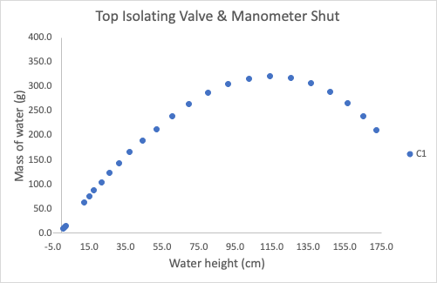

**Figure 2.8:** Case T.C

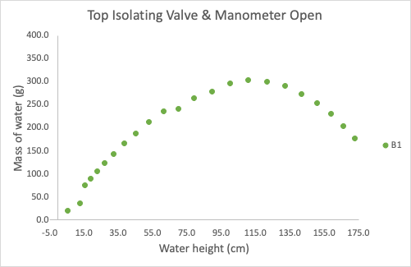

**Figure 2.9:** Case 4.O

| **Figure 2.10:** Data Sets with Same Isolating Valves: Open vs. Closed Top Manometer Valves |
| --- |

*Figure 2.10*plots two groups’ data with the same isolating valve but different manometer valve open conditions. At each pair of data points of about the same water height, the open manometer valve data set shows a greater mass of drained water than the data set with a closed manometer valve.

| **Figure 2.11:** Data From Groups with Manometer Open |
| --- |

*Figure 2.11*plots 4 groups’ data with the same manometer valve open condition but different isolating valves. At a given height it seems like the data sets with higher isolation valves (Top being highest and 3 being lowest) show less mass of drained water than the data set with a lower isolation valve. This is most apparent by the data points closer to the initial height.

## 

## Uncertainties in Data

Figure 2.12 displays the data collected by group C4, which performed the experiment using isolation valve #1 and with the manometer valve closed, with error bars to show the uncertainty of each data point. It can be seen that the error bars barely extend beyond the size of just the data points. This indicates that the uncertainty for collecting data was very small.

| **Figure 2.12:** Case Study of Group C4 With Error Bars |
| --- |

| **Figure 2.13:** Closeup of Error Bars |
| --- |

A closeup of a data point with error bars can be seen in Figure 2.13, both horizontal and vertical error bars are very small and almost invisible without zooming in. Based on the precision and the large range of the instrument used, the errors in each point of the experiment are relatively small. However, it is important to note that the readability of the instruments used is much more accurate than the practical error of the experiment. This means that while the tape measure's smallest unit of measurement is 0.5 mm, the actual error in the measurement will be higher due to other factors, such as parallax error or the accuracy of the markings on the tape. Therefore, an error of 1 mm is estimated for the height. An error of ±1g is estimated for the scale because the readability of the scale is ±1g. It was chosen to not use ±0.5g because small amounts of remaining water in the cup increased the uncertainty.

## 

## Linearization and Fit Line: Case Study Group C4

*Figure 2.14* is a plot of the data from Group C4, where the x-axis is scaled by squaring the difference between the original input value and 115.2cm. This number is significant because the maximum amount of water was drained at 115.2 cm, which represents a vertex of a parabola. Since the symmetry line of a parabola passes through its vertex, remapping each data set with the scaled x-axis above will display a plot with a linear trendline. Thus, the strong linearity of the data in the above figure indicates that a parabola will be a good fit for the data.

| Chart  **Figure 2.14: Case Study of Group C4 Using Squared X-Axis**  Positive refers to [H-115.2] being positive.  Negative refers to [H-115.2] being negative.  These are differentiated since there is an overlap when a value is squared, negative becomes positive. |
| --- |

| **Figure 2.15:** Case Study with Parabolic Trendline |
| --- |

A concave down parabolic curve was fitted in the plot above (*Figure 2.15*). The R2 value is above 0.99 which is indicative of a good fit. However, after plotting the residuals, a secondary trend can be noticed in the data. There appears to be a clear sinusoidal trend also at play in the data. Using these plots, an equation can be arrived at that predicts mass collected for a given height (see *Figure 2.16*and Equation 2.1)**.** The most rightward datapoint is an outlier which is shown to be very far away from the trendline in Figure 2.16.

| **Equation 2.1:** The Equation Used to Model the Sinusoidal Fit |
| --- |

| **Figure 2.16:** Residuals of Case Study With Sinusoidal Fit |
| --- |

# 

# 

# Discussion:

Need a paragraph.

Two governing equations were considered for the derivation of a model for the HVT experiment. These equations are: the Ideal Gas Law, and the Hydrostatic Pressure Equation. The Ideal Gas Law was chosen because the experimental design allows terms of the equation to be derived. For example, when the isolation valve is closed in the experiment, it traps a fixed number of air molecules, and the volume before and after can be calculated. Additionally, the air is not under extreme temperature and pressure so it can be approximated as an ideal gas. The Hydrostatic Equation was chosen because height is one of the measured parameters and allows calculation of the pressures in the main tube caused by water. The combination of these two governing equations leads to the final derivation of a model which accurately predicts real data and supports the initial assumption of a quadratic form.

## 

## Variables Used for Derivation

| **Table X.X: Conditions Volumes by Isolating Valve** | |
| --- | --- |
| Valve # | Clearance Volume (mL) |
| Top | 211 |
| 1 | 391 |
| 2 | 503 |
| 3 | 616 |

| **Table of Variables Used in Derivation** | | |
| --- | --- | --- |
| **Symbol** | **Units** | **Description** |
| Pi | Pa | Air pressure in the main tube before draining |
| Pf | Pa | Air pressure in the main tube after draining |
| Ti | K | Air temperature in the main tube before draining |
| Tf | K | Air temperature in the main tube after draining |
| Vc | m3 | Clearance volume |
| Vi | m3 | Initial volume |
| Vf | m3 | Final volume |
| D | m | Diameter of the main tube |
| d | m | Diameter of the manometer |
| hi | m | Initial height of the water |
| hf | m | Final height of the water |
| H | m | Total height of the main tube |
| ⍴w | kg/m3 | Water density |
| g | N/kg | acceleration of gravity |
| m | kg | Mass of water collected |

## Ideal Gas Law Analysis

The data collected can be rationalized by understanding the theory associated with the expansion of the air in the apparatus. Since the air in the apparatus is trapped during the draining process, the Ideal Gas Law can be used to relate the state of the air before and after draining.

$\frac{P_{i}V_{i}}{T_{i}}=\frac{P_{f}V_{f}}{T_{f}}$ (1)

The initial pressure can be assumed to be atmospheric since the isolating valve had just been closed. The difference between atmospheric pressure at the nozzle and at the isolating valve was assumed to be negligible, since air is significantly less dense than water. This means a change in height would result in a very small change in pressure. Additionally, the experiment was conducted slowly enough to maintain an approximately isothermal process, where

$T_{i}=T_{f}$ (2)

After canceling the temperature on both sides of the ideal gas law equation, the formula can be restated as:

$P_{i}V_{i}$ $=P_{f}V_{f}$ (3)

## 

## Hydrostatic Equation Analysis

By recognizing that the final state of the water in the apparatus is in hydrostatic equilibrium, the final pressure of the trapped air can be determined, per the following equation:

$P_{i}=ρ_{w}gh_{f}+P_{f}$ (4)

The final height of the water (hf) was not recorded. In Professor Sidebotham’s work, “The Hydrostatic Vacuum Tube: a Low-Cost Thermal Fluid Science Laboratory”, a similar experiment was performed and a theoretical model A was proposed with the assumption that hf = hi for calculating this hydrostatic pressure.[5] It was determined in that work that this assumption created a significant deviation from the experimental data. Therefore, it was chosen to avoid the method that assumed pressure before and after could be approximated to be the same. Instead the model uses the drained water to find the change in height and find the pressure after draining. This contributes to a more accurate model.

## Combining Both and Arriving to Final Model

The volume of the trapped air can be broken up further. The first volume to consider is the clearance volume (*Vc*), which consists of the space between the isolating valve and the top of the main tube. The values for each clearance volume were given in a table that was provided to the students before the experiment. The other volume is the cylindrical volume of the air between the top of the main tube (of height H) and the initial height of the water (hi). Combining these two volumes, the initial volume can be expressed as:

$V_{i}=V_{c}+\frac{πD^{2}}{4}\left[H-h_{i}\right]$ (5)

After the water is drained, the water level in the main tube drops from hi to hf, so the difference between the initial and final volume in the main tube can be determined using cylindrical volume formula:

$V_{f}-V_{i}=\frac{πD^{2}}{4}\left[h_{i}-h_{f}\right]$ (6)

However, since the final height (hf) is not yet known, this volume is instead calculated from the mass of the water collected, under the assumption that water is relatively incompressible. Since the water was also drained from the manometer during the experiment, the water collected accounts for the sum of these two volumes. The volume of the water displaced from the manometer tube can be determined by the formula for a cylindrical volume. Thus, volume of the water displaced in the main tube can be calculated by subtracting the water displaced in the manometer by the total volume of the water collected:

$V_{f}-V_{i}=\frac{m}{ρ}-\frac{πd^{2}}{4}\left[h_{i}-h_{0}\right]$ (7)

By equating the above two equations and arranging some terms, the final height of the water in the main tube is expressed as:

$h_{f}=h_{i}-\frac{4m}{πρD^{2}}+\frac{d^{2}}{D^{2}}\left[h_{i}-h_{0}\right]$ (8)

Equation (3) can now be expressed in terms of known values and measured variables:

$\left[P_{atm}\right]\left[\frac{πD^{2}}{4}\left[H-h_{i}\right]+V_{c}\right]=$

$\left[P_{atm}-ρg\left(h_{i}-\frac{4m}{πρD^{2}}+\frac{d^{2}}{D^{2}}\left[h_{i}-h_{0}\right]\right)\right]\left[\frac{πD^{2}}{4}\left[H-h_{i}\right]+V_{c}+\frac{m}{ρ}-\frac{πd^{2}}{4}\left[h_{i}-h_{0}\right]\right]$ (9)

This equation can be reorganized into a quadratic form in terms of the mass of the collected water:

$\left[\frac{4g}{πρD^{2}}\right]m^{2}$

$+\left[\frac{P_{atm}}{ρ}-gh_{i}+g\frac{d^{2}}{D^{2}}\left[h_{i}-h_{0}\right]+g\left[H-h_{i}\right]+\frac{4gV_{c}}{πD^{2}}-\frac{d^{2}}{D^{2}}g\left[h_{i}-h_{0}\right]\right]m$

$-ρg\frac{d^{2}}{D^{2}}\left[h_{i}-h_{0}\right]\left[\frac{πD^{2}}{4}\left[H-h_{i}\right]+V_{c}-\frac{πd^{2}}{4}\left[h_{i}-h_{0}\right]\right]$

$-ρgh_{i}\left[\frac{πD^{2}}{4}\left[H-h_{i}\right]+V_{c}-\frac{πd^{2}}{4}\left[h_{i}-h_{0}\right]\right]-P_{atm}\frac{πd^{2}}{4}\left[h_{i}-h_{0}\right]=0$ (10)

The quadratic formula below is used to solve for the mass of collected water,

$m=\frac{-B+\sqrt{B^{2}-4AC}}{2A}$ (11)

where,

$A=\frac{4g}{πρD^{2}}$ (12)

$B=\frac{P_{atm}}{ρ}-gh_{i}+g\frac{d^{2}}{D^{2}}\left[h_{i}-h_{0}\right]+g\left[H-h_{i}\right]+\frac{4gV_{c}}{πD^{2}}-\frac{d^{2}}{D^{2}}g\left[h_{i}-h_{0}\right]$ (13)

$C= -ρg\frac{d^{2}}{D^{2}}\left[h_{i}-h_{0}\right]\left[\frac{πD^{2}}{4}\left[H-h_{i}\right]+V_{c}-\frac{πd^{2}}{4}\left[h_{i}-h_{0}\right]\right]$

$-ρgh_{i}\left[\frac{πD^{2}}{4}\left[H-h_{i}\right]+V_{c}-\frac{πd^{2}}{4}\left[h_{i}-h_{0}\right]\right]-P_{atm}\frac{πd^{2}}{4}\left[h_{i}-h_{0}\right]$ (14)

## 

## Comparison of Theory to Actual Data: Case Study

This equation can be used to create a theoretical projection of the expected results of the case study. This model is plotted against the experimental data below (*Figure 3.1*).

| **Figure 3.1: Plot of Case Study Theoretical Model and Actual Data** |
| --- |

The general trend for the model is similar to the actual data. However, the theoretical model noticeably diverges from the data as the initial height increases. To understand why the model differs from the experimental results, the subject of uncertainty is revisited. Even though the values of uncertainty were relatively low in the measured quantities of mass and height that comprise the experimental data, the uncertainties of certain parameters in the theoretical equation need to be considered. Below are the values of the parameters used in the theoretical model along with their uncertainties (*Table 3.1*).

| **Table 3.1: All Parameters for Theoretical Equation** | | | |
| --- | --- | --- | --- |
| **Parameter** | **Value** | **Uncertainty** | **Description** |
| d_mano | 0.01086 | ± 0.0005 | m, diameter of manometer |
| D_tank | 0.05847 | ± 0.001 | m, diameter of tank |
| h_exit | -0.723 | ± 0.134 | cm, exit nozzle height |
| P_inf | 29.847 | ± 0.340 | inHg, atmosphere pressure |

## 

## Propagation of Error

Using the Numerical Method for Propagation of Error, an upper and lower bound are calculated for the model (*Figure 3.1*).

| **Figure 3.2:** Plot of Case Study Bounds of Theoretical Model and Actual Data |
| --- |

It was found that uncertainty in the diameter of the manometer had the largest effect on the model. It is likely that the deviation of the original model from the actual data was largely due to an overestimation of the diameter of the manometer. This would also explain why the deviation increased as initial height increased. The theory identifies mass of water collected as the sum of the mass of water displaced from the manometer and the tank. The effect of the change in diameter becomes more pronounced as the measured height increases, since the change in displaced volume would be more dramatic.

## 

## Comparison of Theory to Actual Data: All Valves & Closed Manometer

The equation was used to create a theoretical model for the trials for each isolating valve. The models are plotted against their respective experimental data sets below (*Figure 3.3*).

| **Figure 3.3:** Plot of each Theoretical Model and Actual Data Set |
| --- |

The theoretical model for each valve generally matches the experimental data. As with the case study, however, the model for the other valves also overestimate the collected mass as initial height increases. Using the Numerical Method for Propagation of Error, an upper and lower bound were calculated for the model of each valve (*Figure 3.4*).

| **Figure 3.4: Plot of Bounds for each Theoretical Model and Actual Data Set** |
| --- |

# 

# Conclusion:

The HVT experiment successfully demonstrated the principle of a draining water tank reaching a hydrostatic equilibrium by pulling a partial vacuum. The experiment was performed with different conditions for the isolation valve and manometer valve left opened or closed. Initial analysis of the results pointed towards a quadratic trend for the data. Linearizing the data on a quadratic axis further supported the idea. The derived model equation was also found to be in a quadratic form which agrees with the prediction.

The manometer valve position was not included in the derived equation used to model the experiment. However, it was still predicted that the open manometer valve would result in more drained volume because it increased the effective clearance volume. The results agreed with this prediction and the curve for the open manometer valve was greater than the curve for the closed manometer valve when looking at data for the same isolation valve.

The derived equation still included the other manometer and it very closely modeled all the data with closed manometer valves. Additionally, error propagation was accounted for in the model. It was found that the measurements during the experiment were precise so most of the error was in the modeling equation. Graphs of the upper and lower bounds for the error showed that the model includes the actual data points and accurately predicts the trend.

# 

# Recommendations:

The HVT experiment overall is a well designed experiment that is repeatable and visibly demonstrates the concept of a hydrostatic mechanical equilibrium caused by a partial vacuum. However, some improvements can be made which would improve the experiment.

## Improvements for Procedure

One of the most significant issues encountered was that some conditions (combination of assigned isolation valve and manometer open or closed) had only one dataset and the dataset was erroneous. Appendix II illustrates the large number of erroneous data sets. This poses a significant challenge because the theory cannot be compared to the data set because the experiment was performed incorrectly. Assigning groups conditions such that there would be 2 or 3 data sets per condition would mitigate this problem by greatly increasing the chance that there is at least 1 good data set per condition.

## Improvements for Apparatus

Another way to reduce the problem would be to improve the apparatus. Printing and taping a label to each valve would improve the results. Some conditions have a bad data set because the groups actuated the wrong isolation valve than the one that was assigned. This is from a negligence reading instructions but labels will resolve this problem.

The equation derived to model the HVT also heavily depends on the diameters of the manometer and main tubes. Specifically, the manometer tube diameter contributes the most uncertainty to the mass of water drained. This means obtaining an accurate measurement of its diameter is paramount to creating an accurate model. When constructing the HVT, a small cutoff of the manometer and main tube should be left aside (make sure to clean the burrs). Then a modification to the procedure should be made such that groups will now measure the cutoff section internal diameter with calipers and record the data. This will improve the accuracy of the model since there will be a precise measurement of the tube diameters rather than an estimate.

# 

# 

# References:

American Home Shield. (2022, October 24). What is a plumbing vent pipe and why do I need it? AHS. Retrieved April 5, 2023, from <https://www.ahs.com/home-matters/repair-maintenance/learn-about-plumbing-vents/>

Dinuka, Bongumenzi, Insha, Albert, Geraldine, & Avinash. (2016, December 1). Vernier caliper functions & important parts. Vernier Calipers. Retrieved April 5, 2023, from <https://vernierscaliper.com/vernier-caliper-functions-important-parts-784.html>

Drenth, A., & Sidebotham, G., & Cornwell, P. (2022, August), *The Hydrostatic Vacuum Tube: a Low-Cost Thermal Fluid Science Laboratory* Paper presented at 2022 ASEE Annual Conference & Exposition, Minneapolis, MN. https://peer.asee.org/41469

Field, J. (2022, January 1). How to use a food scale to weigh ingredients. Pastry Chef Online. Retrieved April 5, 2023, from <https://pastrychefonline.com/importance-of-using-a-scale-fundamental-friday/>

*Outdoor Barometer Thermometer Hygrometer - 5in Barometer Weather Station , Barometer for Home Wall, Fishing Boat, Baby Room, Office*. https://www.amazon.com/Aowutus-Outdoor-Barometer-Thermometer-Hygrometer/dp/B099J884G4. Accessed 6 Apr. 2023.

# 

# Appendix I: Raw Data

Group A1:

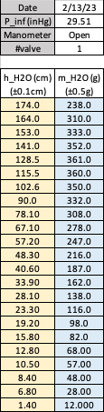

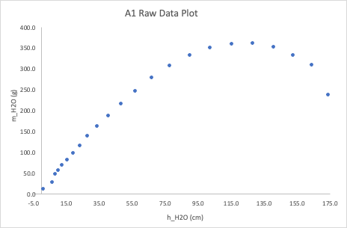

*Figure R1: Group A1 Raw Data Plot*

Group A2:

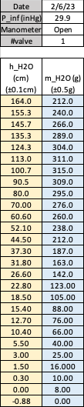

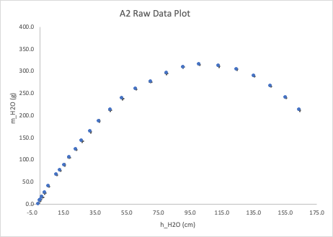

*Figure R2: Group A2 Raw Data Plot*

Group A3:

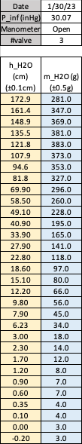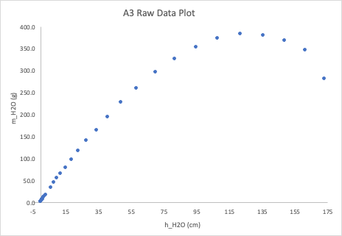

*Figure R3: Group A3 Raw Data Plot*

Group A4: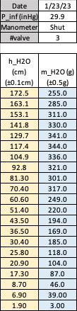

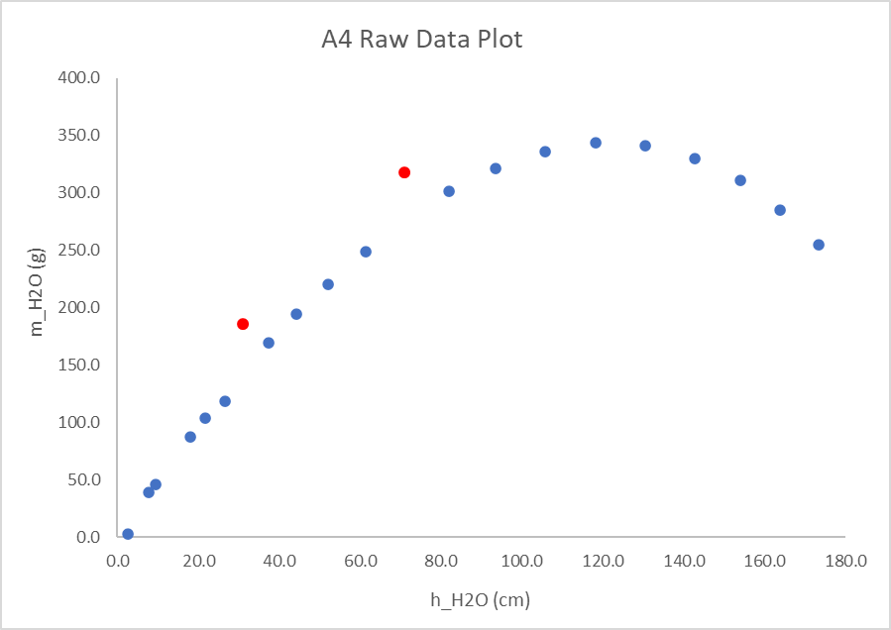

*Figure R4: Group A4 Raw Data Plot*

Group B1: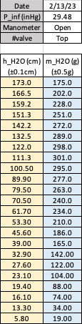

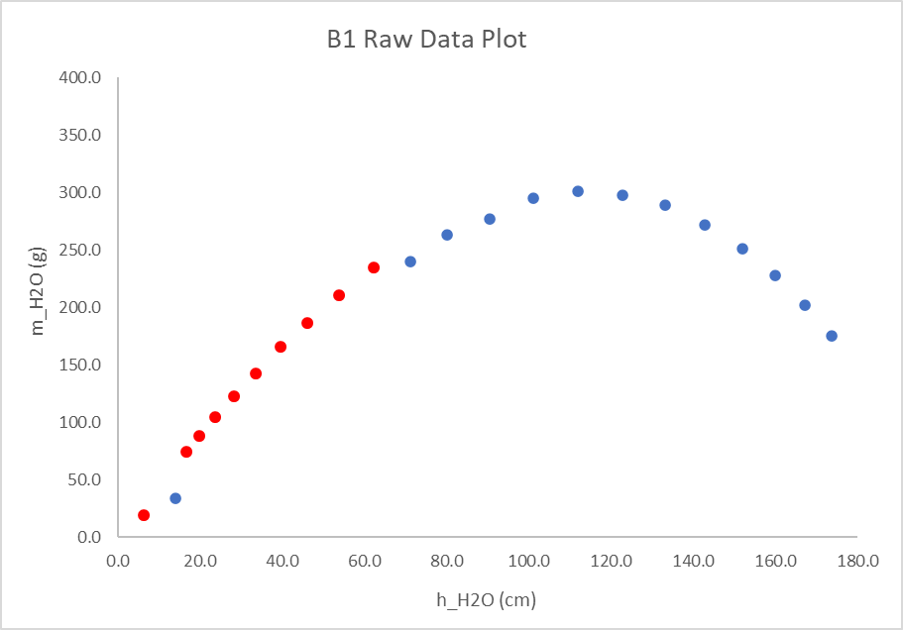

*Figure R5: Group B1 Raw Data Plot*

Group B2:

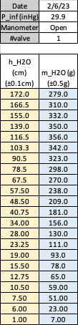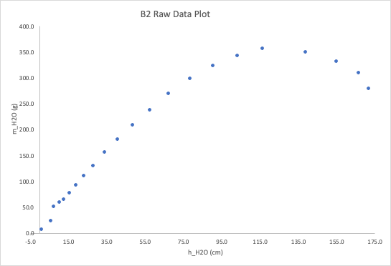

*Figure R6: Group B2 Raw Data Plot*

Group B3: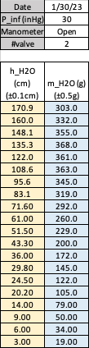

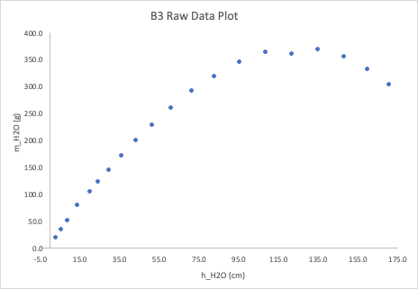

*Figure R7: Group B3 Raw Data Plot*

Group B4: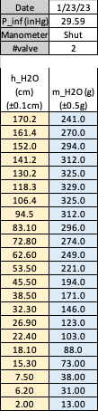

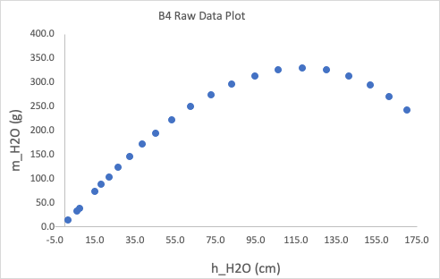

*Figure R8: Group B4 Raw Data Plot*

Group C1: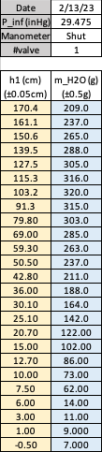

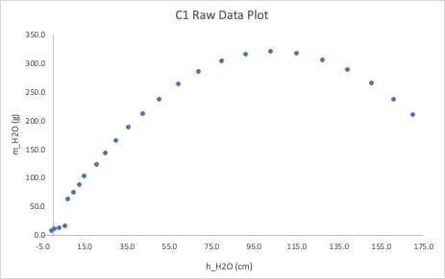

*Figure R9: Group C1 Raw Data Plot*

## 

Group C2: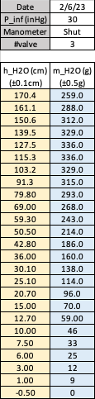

# 

*Figure R10: Group C2 Raw Data Plot*

Group C3:

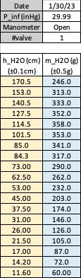

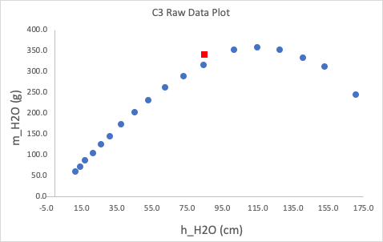

*Figure R11: Group C3 Raw Data Plot*

# 

# 

# 

# 

# 

# 

Group C4:

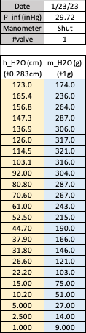

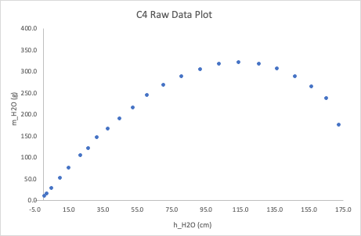

*Figure R12: Group C4 Raw Data Plot*

# Appendix II: Erroneous Data & Correction

This section highlights datasets which showed significant errors. Some of these errors can be corrected or ignored because they are minor mistakes. However, some of the other data sets show errors too significant to be corrected and must be discarded.

## Kept Datasets: Group A4, B4, C3

In the data plot *Figure R4* (See Appendix I), there are 2 outliers that deviate from the trend. Both outliers are shifted upwards by around 40 grams, which is coincidentally the same weight as the cup used to hold water. This fact implies that the tare weight was included for the outliers. After subtracting the mass of the outlier values by 40 grams, the data points now accurately follow the trend, as shown in *Figure A.1*.

| ***Figure A.1:***Group A4 Corrected Data Plot |
| --- |

The dataset from group B4 is shown in Figure A.2. The error here is that the group recorded the wrong offset of the nozzle from the start of the tape measure. This results in the data not intersecting the origin in the plot with adjusted offset. Table 2.A shows that group B4 collected this data wrong and their reported value was excluded. After adjusting using the average offset, Figure A.3 shows B4 data follows the expected trend and intersects the origin.

| **Figure A.2:** Group B4 Dataset not Intersecting Origin |
| --- |

| Chart  **Figure A.3:** Group B4 Dataset Fixed by Correcting Offset |
| --- |

The dataset from group C3 is shown in Figure A.4. The erroneous data point is a red square. Although this error cannot be corrected, it was chosen to keep this data set instead of discarding it. This is because there is only 1 point that is wrong and the rest of the points appear to be correct. The minor error will not cause a major disagreement between the theoretical model and the data set.

| **Figure A.4:** Group C3 Raw Data with Highlighted Error |
| --- |

## 

## Discarded Datasets: Group B1, C1

Figure A.5 is the raw data plot obtained from group B1. The erroneous data points are highlighted using red square markers. It can be seen that the data points are all shifted upwards than what the trend would be. Figure A.6 confirms that group B1 did not make an error forgetting to taring the cup mass. Likely group B1 recorded the height after draining or some other gross error resulting in uncorrectable data. This led to the decision to discard the data.

| **Figure A.5:** Group B1 Raw Data Plot with Highlighted Errors |
| --- |

| Chart  **Figure A.6:** Attempt to Correct B1 |
| --- |

Figure A.6 is a graph of the dataset for group C1. The erroneous data is highlighted red. The data points are all clustered in the bottom left and there is a large gap between the cluster and the rest of the normal data. This suggests that group C1 performed the experiment wrong in some way and led to the decision to discard their dataset.

| Chart  **Figure A.6:** Group C1 Data with Errors in Red |
| --- |

1. American Home Shield. (2022, October 24). *What is a plumbing vent pipe and why do I need it?* AHS. Retrieved April 5, 2023, from https://www.ahs.com/home-matters/repair-maintenance/learn-about-plumbing-vents/
2. Dinuka, Bongumenzi, Insha, Albert, Geraldine, & Avinash. (2016, December 1). *Vernier caliper functions & important parts*. Vernier Calipers. Retrieved April 5, 2023, from https://vernierscaliper.com/vernier-caliper-functions-important-parts-784.html
3. Field, J. (2022, January 1). *How to use a food scale to weigh ingredients*. Pastry Chef Online. Retrieved April 5, 2023, from https://pastrychefonline.com/importance-of-using-a-scale-fundamental-friday/
4. *Outdoor Barometer Thermometer Hygrometer - 5in Barometer Weather Station , Barometer for Home Wall, Fishing Boat, Baby Room, Office*. https://www.amazon.com/Aowutus-Outdoor-Barometer-Thermometer-Hygrometer/dp/B099J884G4. Accessed 6 Apr. 2023.
5. Drenth, A., & Sidebotham, G., & Cornwell, P. (2022, August), The Hydrostatic Vacuum Tube: a Low-Cost Thermal Fluid Science Laboratory Paper presented at 2022 ASEE Annual Conference & Exposition, Minneapolis, MN.

  